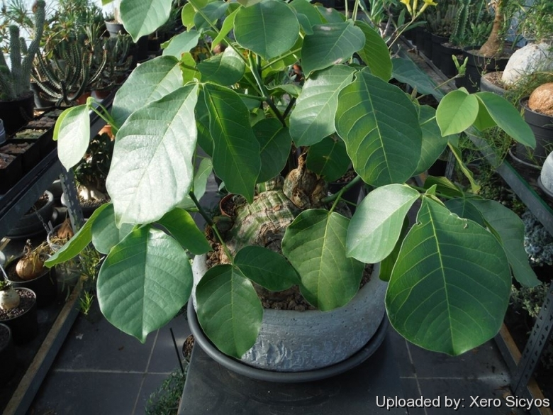 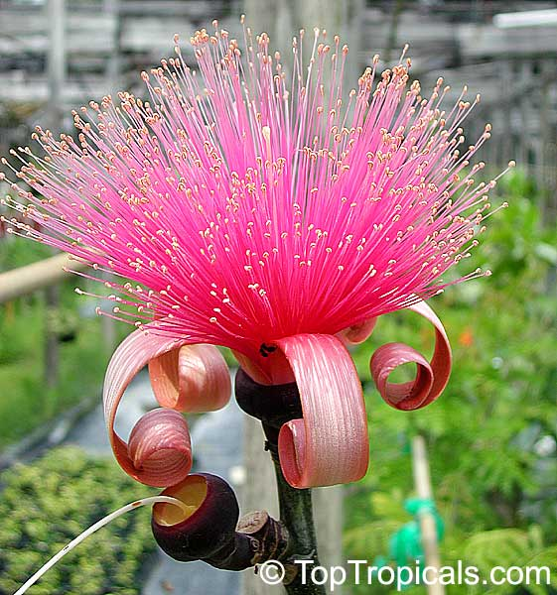

(<http://www.llifle.com/photos/Pseudobombax_ellipticum_24839_l.jpg>) (<https://toptropicals.com/pics/garden/05/n4/4832.jpg>)

**Shaving Brush Tree**

*Pseudobombax ellipticum*

**Category:**

Trees

Cactus and Succulents

**Foliage Color:**

Burgundy

**Water Requirements:**

Drought-tolerant; suitable for xeriscaping

**Height:**

12-15 ft. (3.6-4.7 m)

15-20 ft. (4.7-6 m)

20-30 ft. (6-9 m)

30-40 ft. (9-12 m)

over 40 ft. (12 m)

**Spacing:**

15-20 ft. (4.7-6 m)

20-30 ft. (6-9 m)

30-40 ft. (9-12 m)

**Hardiness:**

USDA Zone 9b: to -3.8 °C (25 °F)

USDA Zone 10a: to -1.1 °C (30 °F)

USDA Zone 10b: to 1.7 °C (35 °F)

USDA Zone 11: above 4.5 °C (40 °F)

**Sun Exposure:**

Full Sun

Light Shade

**Danger:**

[Unknown - Tell us](http://davesgarden.com/guides/pf/addoptions.php?pid=48953&namenum=5)

**Bloom Color:**

Pink

White/Near White

**Bloom Time:**

Mid Spring

Late Spring/Early Summer

**Foliage:**

Deciduous

**Patent Information:**

Non-patented

**Propagation Methods:**

From woody stem cuttings

From hardwood cuttings

From seed; germinate in vitro in gelatin, agar or other medium

**Seed Collecting:**

Collect seedhead/pod when flowers fade; allow to dry